Seminar: Geodata analysis and modeling

University of Bern, Spring Semester 2019

**Hydrological River Network –**

**Simplification of network information**

Supervisors

Pascal Horton,

Jorge Ramirez,

Andreas Zischg

Carine Hürbin, matriculation nr 14-104-137

Mukadem Brumand, matriculation nr

Submitted

23rd of December 2019

**Table of Contents**

**1.** **Introduction** 3

**2.** **Directions for Use** 3

**3.** **Development Process and Limitations** 4

Appendix: Source Material and References 6

# **Introduction**

The programming work documented in this report shows our work on a simplification of the complete river network existing in Switzerland. For this, we used the Python Interface and Python Commands of the open-source software QGIS. This simplification can be used in cartographic generalisation, e.g. as a separate zoom level for the river network displayed on web pages with interactive maps. The advantage of the simplification is that maps are easier to handle due to smaller data sizes. Further, they can be more easily implemented on web pages and use less bandwidth, thus load faster and are more convenient for the users.

The tools we used are Python 3.7, the Python IDE PyCharm 2019.3 Community Edition and QGIS 3.10.1 "A Coruña". This script was created in the context of the seminar "Geodata analysis and modeling" of the master program in Geography at the university of Bern (Switzerland), supervised by Pascal Horton, Andreas Zischg and Jorge Ramirez.

We would like to thank our supervisors Pascal Horton, Andreas Zischg and Jorge Ramirez for introducing us to our topic and supporting us throughout our learning process. While we worked on this project, we could always look to them for help on the programming and scripting, as they were answering our questions as well as possible.

# **Directions for Use**

For the script to work, a dataset containing the river network information is needed. In our case the corresponding shapefile (ESRI Shapefile, .shp) with the river network lines (vector type) was provided to us (see Appendix). Further, a dataset containing a digital elevation model (DEM) is needed. This dataset was also given to us. The DEM contains information about elevation on every single point of the perimeter as an ASCII / ESRI Grid file (.asc type).

We applied our script to the case of Switzerland; however, by changing the paths and exact file names in the script it is possible to apply it to other datasets. ESRI Shapefile is a file type which cannot be handled by many software applications, but in case of QGIS shapefiles can be handled and modified without restriction. Modifications on a shapefile will usually be saved in QGIS’s own project file type QGZ (.qgz), but the software is also able to save modified shapefiles in new layers, also in the original .shp format. Since it is free open-source software which comes also with a Python console, QGIS was our preferred choice of software for checking and exploring our source material.

# **Development Process and Limitations**

Before starting our actual coding work, it was necessary to set up the tools needed on our machines (laptops). The basic prerequisite of starting with writing code was to install Python 3.7. itself on our machines, as it was not preinstalled. First, it was not possible to get the Python package GeoPandas to work on our setup, although we wanted to use GeoPandas, as it was recommended for our task. The installation worked out when we on recommendation of a friend used an Anaconda Python Environment instead of the basic virtual environment used in the JetBrains Pycharm IDE by standard. Since Anaconda checks for dependencies when installing a specific package and installs them at the same time (see Appendix, "Why Anaconda", 2019), which we did not know in the beginning, we managed to install GeoPandas in the end.

Firstly, with QGIS we opened and analysed our source materials. While studying the measuring gauges we noticed that the marker points of the measuring gauges are not aligned with the river network lines, meaning that the measuring gauges are not exactly placed there where the rivers flow, but some space apart. Since our script is not intended to rely heavily on these marker points (it does not actively process them, rather they are used for additional information) and we were unaware how to fix this issue apart from the strenuous work of relocating every single marker point manually (there are approx. 200 marker points in the perimeter), we had to decide to leave the issue pending.

Further, as we researched to look up information on the GeoPandas package to apply it on our task, we found that there was not much material to be found apart from the basic documentation (see Appendix, "GeoPandas Documentation", 2019) which we found hardly applicable to our task. After researching into the QGIS Python Console documentation, we decided to take advantage of the Python console integrated into QGIS and the commands connected to it to acieve the desired processing through QGIS, which results in a kind of "QGIS standalone application" or "pseudo-plugin" which can be used outside of QGIS even though it takes use of the program a lot (see Appendix, QGIS PyGIS Developer Cookbook, 2019). The simplification algorithm used by the QGIS was implemented by Douglas & Peucker (1973) and Ramer (1972).

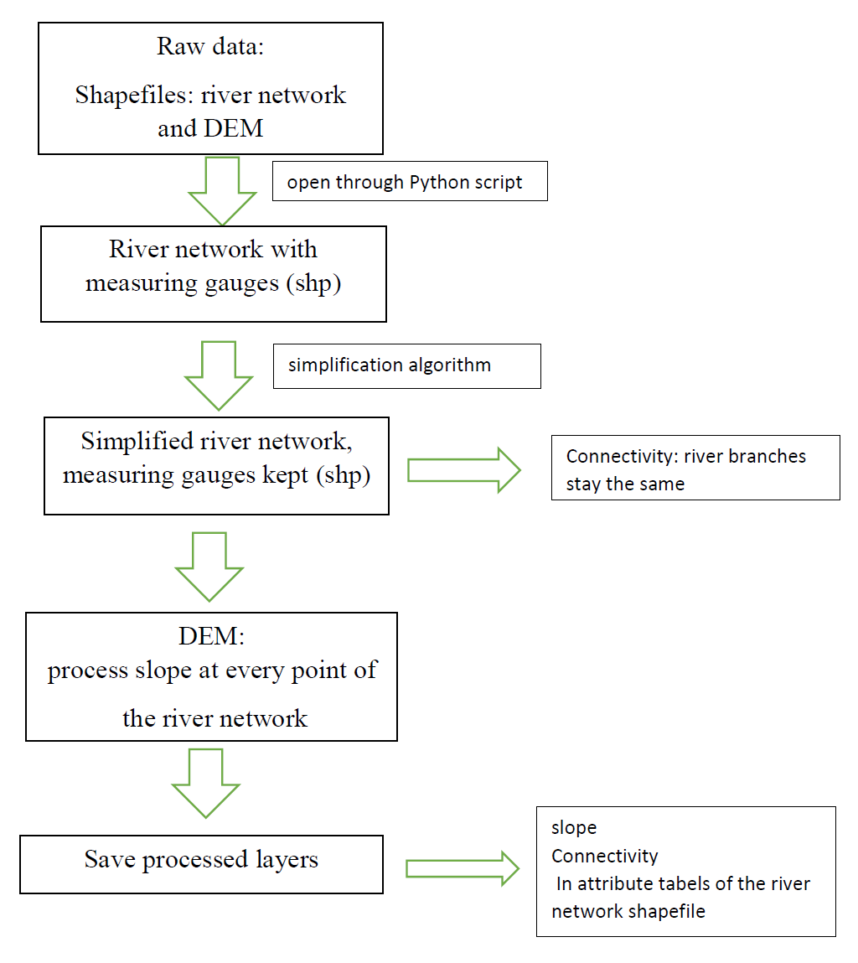

Illustration: Flow Chart Script Processing for River Network Simplification. Source: Own illustration.

During development process our operating systems (Windows 10) and QGIS were updated and changed to new versions several times. On the first installation used for analysing our source material the latest QGIS version was 3.6. As we finished our coding work QGIS was updated to version 10.1 "A Coruña". It is possible that these changes could lead to subtle errors or conflicts which would render our script flawed. Also our script is designed to work which specific file types; therefore it may not work with others which are not described here.

# Appendix: Source Material and References

Anaconda (2019): Why Anaconda? Online on:  
https://www.anaconda.com/why-anaconda/ (year: 2019) (last access: 2019).

Douglas, David & Peucker, Thomas (1973): Algorithms for the reduction of the number of points required to represent a digitized line or its caricature", The Canadian Cartographer 10(2), 112–122.

Eidgenössisches Departement für Verteidigung, Bevölkerungsschutz und Sport VBS armasuisse Bundesamt für Landestopografie swisstopo (2012): Objektkatalog swissTLM 3D.

Eidgenössisches Departement für Verteidigung, Bevölkerungsschutz und Sport VBS armasuisse Bundesamt für Landestopografie swisstopo (2012): DM25 Matrixmodell.   
Online on: https://www.geocat.ch/geonetwork/srv/eng/md.viewer#/full_view/ad654fde-9b0d-4385-8a4a-b59f50a42e25 (year: 2001/2019) (last access: 16.12.2019).   
Available at: https://shop.swisstopo.admin.ch/en/products/height_models/dhm25 (last access: 16.12.2019)

GeoPandas (2019): GeoPandas Documentation. Online on:  
http://GeoPandas.org/ (year: 2019) (last access: 16.12.2019)

QGIS PyGIS Developer Cookbook (2019): QGIS and Python Introduction. Online on:  
https://docs.qgis.org/3.4/en/docs/pyqgis_developer_cookbook/intro.html#technical-notes-on-pyqt-and-sip (year: 2019) (last access: 16.12.2019)

Ramer, Urs (1972): An iterative procedure for the polygonal approximation of plane curves. Computer Graphics and Image Processing, 1(3), 244–256.